RG-08 Data Manual
Industrial LoRaWAN Wireless Data Acquisition Gateway

Version 1.3
Date 2026-05-28

Disclaimer and Copyright Notice
The information in this document, including URLs referenced for information, is subject to change without notice. This document is provided "as is" without warranty of any kind, whether express or implied, including but not limited to the implied warranties of merchantability, fitness for a particular purpose, or non-infringement, and any warranties arising from a proposal, specification, or sample mentioned elsewhere. This document assumes no responsibility for any direct or indirect damages arising from the use of the information contained herein.

Notice
Due to product version upgrades or other reasons, the content of this manual may change. Shenzhen Ai-Thinker Technology Co., Ltd. reserves the right to modify the content of this manual without any notice or prompt. This manual is intended only as a usage guide. Shenzhen Ai-Thinker Technology Co., Ltd. makes every effort to provide accurate information in this manual, but does not guarantee that the content is completely error-free. All content in this manual does not constitute any form of warranty.

CONTENT
CONTENT 1
1. Product Introduction 5
1.1 Product Features 6
1.2 Ordering Information 7
1.3 Functional Parameters 8
2. Configuration 9
2.1 AP Parameters 9
2.2 Parameter Configuration 9
2.2.1 Frequency Channel Settings 9
2.2.2 Common Frequency Channels and Radio Mapping 10
▪ Common Frequency 10
▪ Frequency Range(MHz) 10
▪ Radio0(Hz) 10
▪ Radio1(Hz) 10
▪ CN470_0 10
▪ 470.3-471.7 10
▪ 470600000 10
▪ 471400000 10
▪ CN470_10 10
▪ 486.3-487.7 10
▪ 486600000 10
▪ 487400000 10
▪ EU868 10
▪ 868.1,868.3,868.5,867.1, 10
▪ 867.3,867.5,867.7,867.9 10
▪ 867500000 10
▪ 868500000 10
▪ EU433 10
▪ 433.175,433.375,433.575,433.775 10
▪ 433.975,434.175,434.375,434.575 11
▪ 433475000 10
▪ 434275000 10
▪ US915_0 11
▪ 902.3-907.7 11
▪ 902700000 11
▪ 907400000 11
▪ US915_1 11
▪ 903.9-905.3 11
▪ 904300000 11
▪ 905000000 11
▪ AU915_0 11
▪ 915.2-916.6 11
▪ 915600000 11
▪ 916300000 11
▪ AS923 11
▪ 922.0-923.4 11
▪ 922300000 11
▪ 923100000 11
2.2.3 Ai-Thinker Official LoRaWAN NS 11
2.3 WEB Configuration 11
2.3.1 General Overview 11
2.3.2 Gateway Information Page 12
2.3.2 Configuration Page 12
2.3.3 Maintenance Page 14
2.4 Command Line Configuration 15
2.4.1 Serial Port Connection 15
2.4.2 Command Description 15
3. Function Introduction 18
3.1 Multi-Network Interface Management 18
3.2 LED Indicator Status 18
4. Acceptance Testing Method 19
5. NS Connection 20
5.1 Connecting with ChirpStack 20
5.1 Connecting with TTN 20
6. Gateway Configuration Channel 22
6.1 Standard MQTT Channel 22
6.1.1 Periodic Packet 22
6.1.2 Modify Gateway Configuration 23
6.1.3 Reboot 24
6.1.4 Upgrade 24
6.2 ThingsBoard MQTT Channel 25
6.2.1 Gateway Information Packet 25
6.2.2 Heartbeat Packet 26
6.2.3 Modify Gateway Configuration 26
6.2.4 Query Gateway Status and Configuration 27
6.2.5 Reboot 29
6.2.6 Factory Reset 29
6.2.7 Upgrade 29
7. Using ChirpStack 30
7.1 ChirpStack Introduction 30
7.2 Gateway Registration 30
7.3 Device Registration 31
7.3.1 Create Device Profiles 31
7.3.2 Create Application 31
7.3.3 Register Device 32
7.4 View Data 33
7.4.1 View Gateway Data 33
7.4.2 View Node Data 33

1. Product Introduction
RG-08LTE/ETH is a smart data acquisition gateway that uses LoRaWAN and 4G wireless transmission to implement data transmission functions. It facilitates remote, wireless, and networked communication, enabling easy interconnection with platforms. It significantly reduces the complex development process of wireless products, allowing your products to enter the market faster at lower cost. It can be widely applied in power systems, industrial monitoring, traffic management, meteorology, water treatment, environmental monitoring, coal mining, petroleum, and other industries.

This product series provides 1 Ethernet interface, 8 LoRaWAN wireless receiving channels, 1 transmitting channel, 4G wireless interconnection platform, and WIFI configuration/networking.

It features wide network coverage (4G), flexible and fast networking (ready to use upon installation), and low operating costs (billing by data traffic or duration). It can be applied in power systems, industrial monitoring, traffic management, meteorology, water treatment, environmental mon
monitoring, coal mining, petroleum, and other industries.

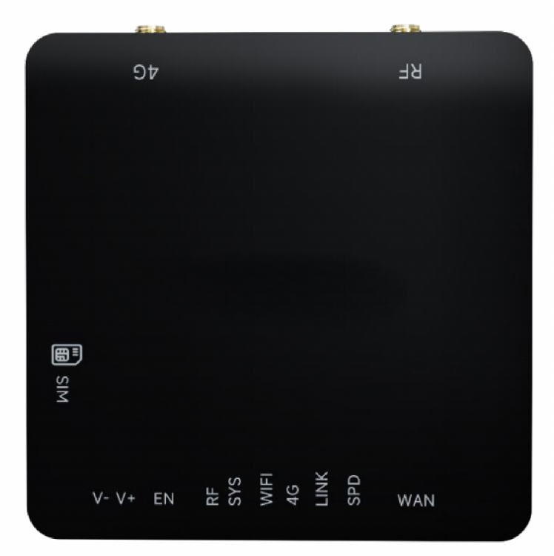

1.1 Product Features
◆ High-performance embedded hardware platform
◆ Industrial-grade Cat.1 4G module
◆ Wide voltage input DC 9~28V, industrial-grade stability
◆ Group pulse: power supply ±2kV, communication line ±4kV
◆ Humidity range: 10%~95%, feature-rich
◆ Built-in web page for convenient viewing and configuration of system functions
◆ Supports UDP Packet Forward protocol, easily connects with major LoRaWAN cloud platforms
◆ Supports remote management and configuration of devices, OTA upgrade
◆ LED indicators for viewing data channel status, such as wireless connection, data transmission/reception
◆ WIFI/4G/Ethernet multi-network backup with automatic switching, fully redundant data links

1.2 Ordering Information
Model | Scenario | 4G Network
RG-08ETH | Indoor | No
RG-08LTE | Indoor | Yes

1.3 Functional Parameters
Category | Parameter | Value
Hardware Parameters | Operating Voltage | DC 9~28
Hardware Parameters | Standby Power Consumption | 0.72W(12V)
Physical Characteristics | Enclosure | VO flame-retardant material
Physical Characteristics | Dimensions | 95*95*18mm  (L*W*H, excluding terminals)
Physical Characteristics | Operating Temperature | -35℃~70℃
Physical Characteristics | Storage Temperature | -45℃~90℃
Physical Characteristics | Operating Humidity | 10%~90% (non-condensing)
Communication Interfaces | Network Access Method | 4G Cat1,Ethernet,WIFI(2.4G)
Communication Interfaces | LoRa Frequency Band | 470/868/915/923 optional
Functions | NS Connection | UDP Packet Forward
Functions | Management Port | MQTT Native/Things Board
Functions | Configuration | WEB, MQTT remote Configuration
Functions | Upgrade | WEB Upgrade, OTA
Functions | Multi-NIC Auto Switch | 4G, Ethernet, WIFI auto switch
Functions | Supported Frequency Bands | CN470/EU868/US915/AU915/AS923

2. Configuration

2.1 AP Parameters
The device enters AP mode upon power-up. AP mode configuration is as follows:

# WIFI configuration in AP mode
SSID:LoRaGW-xxxxxx
password:loragwwifi

xxxxxx is the last 6 digits of the SN

WEB address:192.168.4.1

2.2 Parameter Configuration

2.2.1 Frequency Channel Settings
The gateway has 8 channels, controlled by two radio chips: radio0 and radio1. Channel frequency settings are implemented by configuring radio0 and radio1. The mapping of 8 frequency channels to radio0 and radio1 varies by region. See details below.
- CN470
CN470(typically radio0 and radio1 differ by 800KHz, default radio=470600000Hz,radio1=471400000Hz)
freq0 = RADIO0-300KHz,default470.3MHz
freq1 = RADIO0-100KHz,default470.5MHz
freq2 = RADIO0+100KHz,default470.7MHz
freq3 = RADIO0+300KHz,default470.9MHz
freq4 = RADIO1-300KHz,default471.1MHz
freq5 = RADIO1-100KHz,default471.3MHz
freq6 = RADIO1+100KHz,default471.5MHz
freq7 = RADIO1+300KHz,default471.7MHz
- EU868
EU868(defaultradio=867500000Hz,radio1=868500000Hz)
freq0 = RADIO1-400KHz default868.1MHz
freq1 = RADIO1-200KHz default868.3MHz
freq2 = RADIO1 default868.5MHz
freq3 = RADIO0-400KHz default867.1MHz
freq4 = RADIO0-200KHz default867.3MHz
freq5 = RADIO0 default867.5MHz
freq6 = RADIO0+200KHz default867.7MHz
freq7 = RADIO0+400KHz default867.9MHz
- US915
US915(defaultradio=904300000Hz,radio1=905000000Hz) //US915_1
freq0 = RADIO0-400KHz default903.9MHz
freq1 = RADIO0-200KHz default904.1MHz
freq2 = RADIO0 default904.3MHz
freq3 = RADIO0+200KHz default904.5MHz
freq4 = RADIO1-300KHz default904.7MHz
freq5 = RADIO1-100KHz default904.9MHz
freq6 = RADIO1+100KHz default905.1MHz
freq7 = RADIO1+300KHz default905.3MHz

chan_LoRa_Std = radio0+300Khz,default904.6MHz
- AU915
AU915(defaultradio=915600000Hz,radio1=916300000Hz) //AU915_0
freq0 = RADIO0-400KHz default915.2MHz
freq1 = RADIO0-200KHz default915.4MHz
freq2 = RADIO0 default915.6MHz
freq3 = RADIO0+200KHz default915.8MHz
freq4 = RADIO1-300KHz default916.0MHz
freq5 = RADIO1-100KHz default916.2MHz
freq6 = RADIO1+100KHz default916.4MHz
freq7 = RADIO1+300KHz default916.6MHz

chan_LoRa_Std = radio0+300Khz,default915.9MHz
- AS923
AS923(defaultradio=922300000Hz,radio1=923100000Hz) //AS923
freq0 = RADIO0-300KHz default922.0MHz
freq1 = RADIO0-100KHz default922.3MHz
freq2 = RADIO0+100KHZ default922.4MHz
freq3 = RADIO0+300KHz default922.6MHz
freq4 = RADIO1-300KHz default922.8MHz
freq5 = RADIO1-100KHz default923.0MHz
freq6 = RADIO1+100KHz default923.2MHz
freq7 = RADIO1+300KHz default923.4MHz

chan_LoRa_Std = radio0+300Khz,default922.6MHz

2.2.2 Common Frequency Channels and Radio Mapping
Common Frequency | Frequency Range(MHz) | Radio0(Hz) | Radio1(Hz)
CN470_0 | 470.3-471.7 | 470600000 | 471400000
CN470_10 | 486.3-487.7 | 486600000 | 487400000
EU868 | 868.1,868.3,868.5,867.1,  867.3,867.5,867.7,867.9 | 867500000 | 868500000
EU433 | 433.175,433.375,433.575,433.775  433.975,434.175,434.375,434.575 | 433475000 | 434275000
US915_0 | 902.3-907.7 | 902700000 | 907400000
US915_1 | 903.9-905.3 | 904300000 | 905000000
AU915_0 | 915.2-916.6 | 915600000 | 916300000
AS923 | 922.0-923.4 | 922300000 | 923100000

2.2.3 Ai-Thinker Official LoRaWAN NS
Test NS, domain:lora.iot-aithings.com,IP:47.113.96.150
WEB address:http://lora.iot-aithings.comhttp://lora.iot-aithings.com
Packet forward address:
● EU868: lora.iot-aithings.com:1700
● AS923: lora.iot-aithings.com:1701
● US915_0: lora.iot-aithings.com:1702
● AU915_0: lora.iot-aithings.com:1703
● KR920: lora.iot-aithings.com:1704
● RU864: lora.iot-aithings.com:1705
● IN865: lora.iot-aithings.com:1706
● CN470_0: lora.iot-aithings.com:1707
To use Ai-Thinker's official LoRaWAN NS, please contact official customer service to activate an enterprise account.

2.3 WEB Configuration

2.3.1 General Overview
● Menu bar: refresh and restart the gateway;
● GW Info: gateway information page;
● Configuration: gateway configuration page for viewing and modifying gateway settings. Any configuration changes require a restart to take effect;
● Maintenance: maintenance page for device upgrade and factory reset;

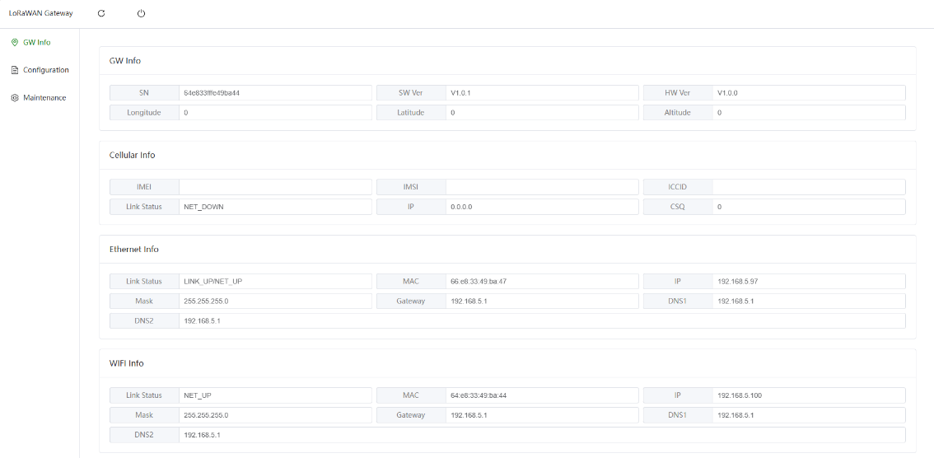

2.3.2 Gateway Information Page
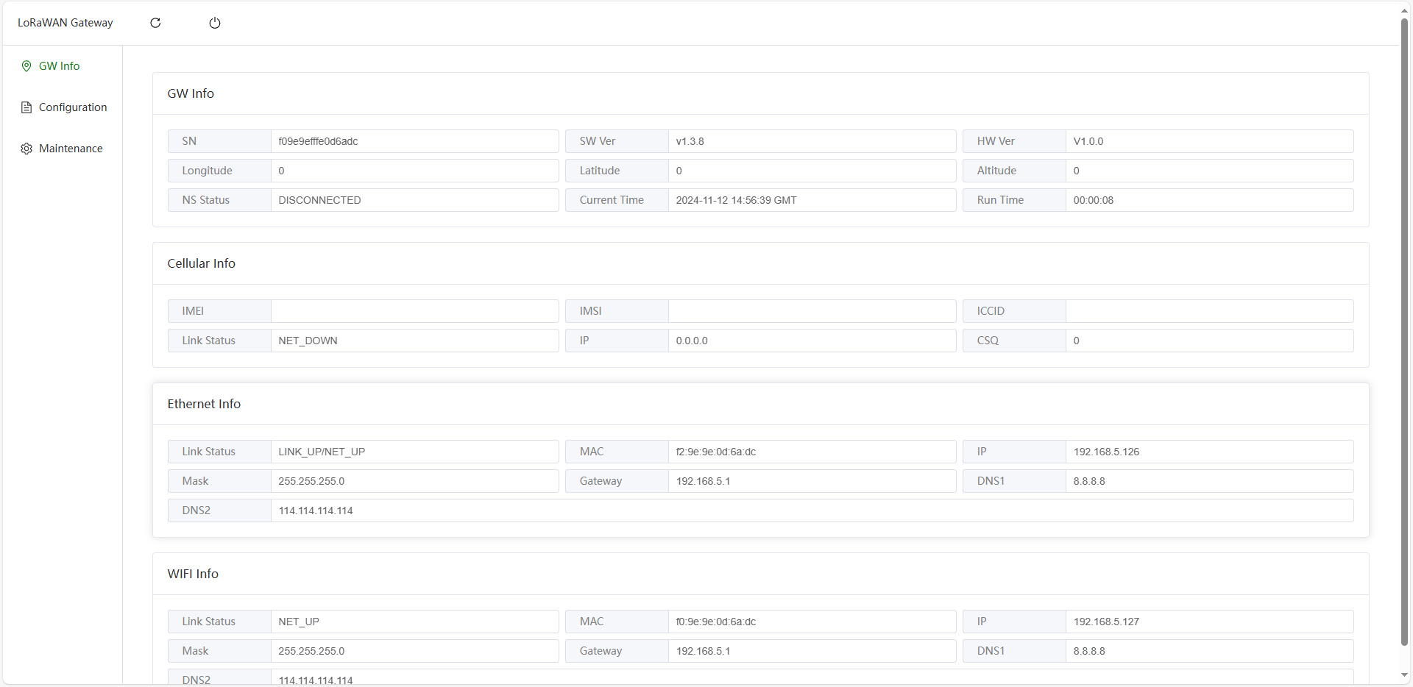
● The gateway SN is generated from the MAC address. The MAC address is IEEE unique, thus typically globally unique;
● The default Gateway ID (GWEUI) is the same as the SN. The Gateway ID can also be modified on the configuration page;
● WIFI Info displays the WIFI STA connection status. It is not displayed by default and will be shown after enabling WIFI STA;
● IMEI is the unique ID of the cellular module, ICCID is the SIM card number (not a phone number)

2.3.2 Configuration Page
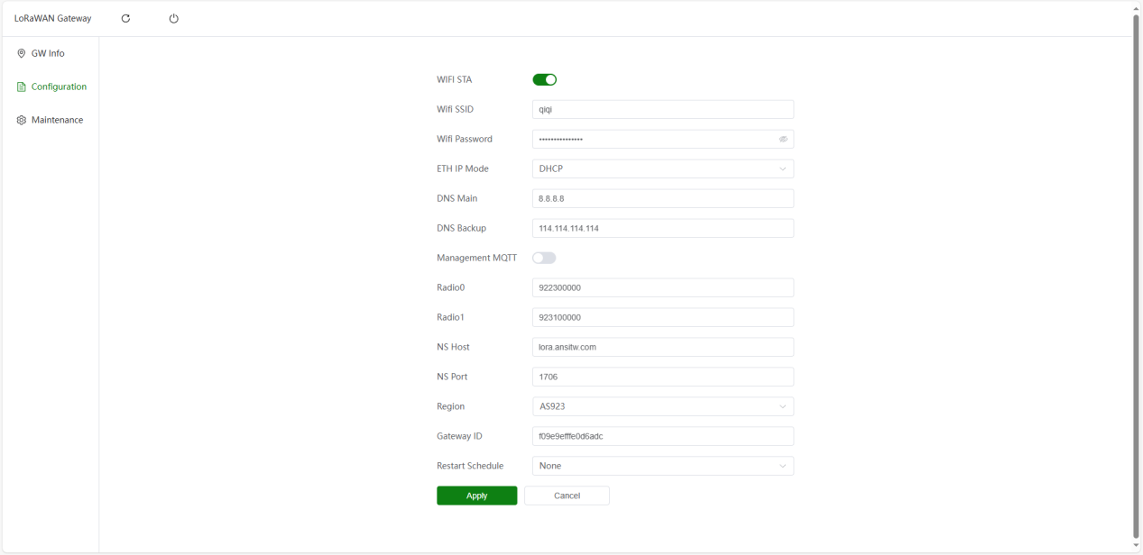
● WIFI STA: supports connecting to the network via WIFI access point;
● Management MQTT: used to configure MQTT parameters for the management channel;
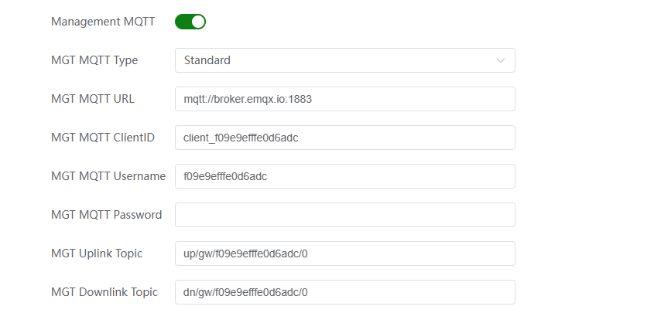
◆ When enabled, gateway heartbeat packets are received periodically (60s) to keep the gateway online and synchronize gateway configuration
◆ Supports standard MQTT and ThingsBoard
◆ Configurable Username, Password, ClientID
◆ The management channel does not currently support MQTTS
● Frequency channel configuration: requires setting Region, Radio0, and Radio1;
● NS direction: configured by modifying NS Host and NS Port, defaulting to the test NS;
◆ Currently only supports UDP Packet Forward
◆ Major NS platforms such as ChirpStack, TTN, and Tencent Cloud all support UDP Packet Forward
● Restart Schedule: supports configuring a restart plan, either at fixed intervals or at a specified time
Note:
- All modifications on the above pages require clicking Apply first, then restarting to take effect

2.3.3 Maintenance Page
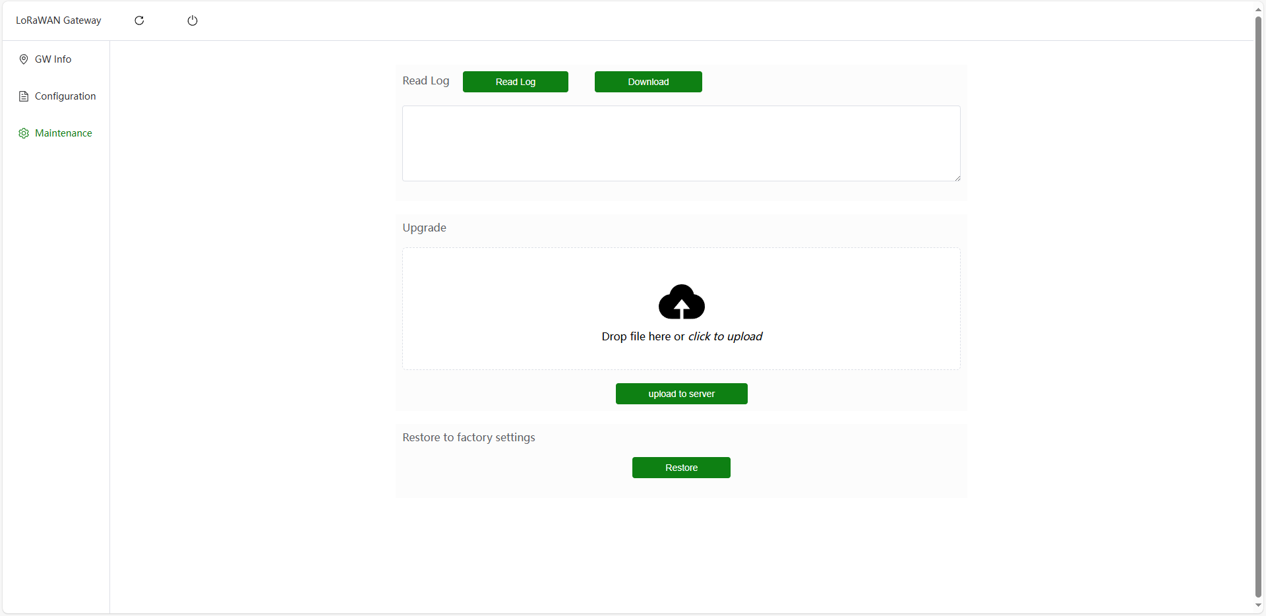
● Read Log: The device saves simple logs, including restart events, network status changes, and NS connection status changes. You can read the logs stored on the device;
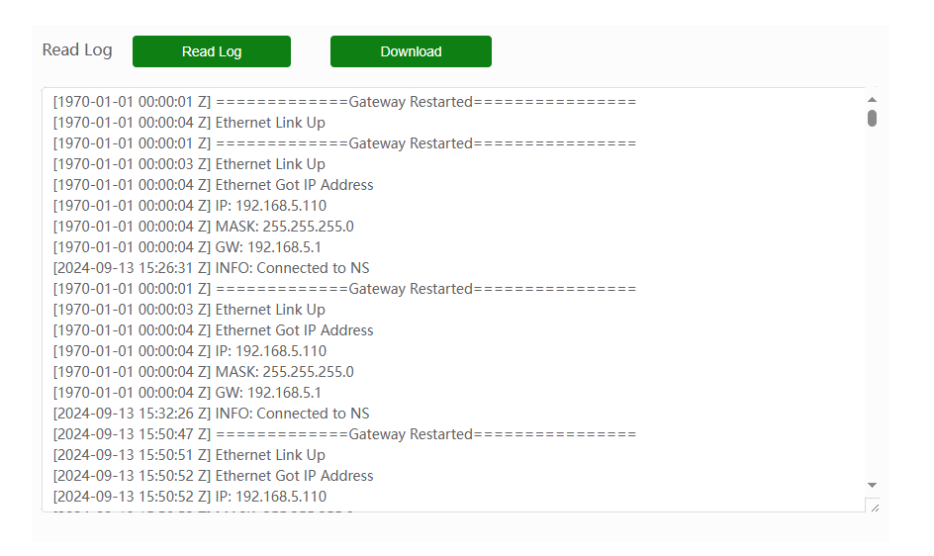
● Upgrade: drag or select a file to perform an upgrade;
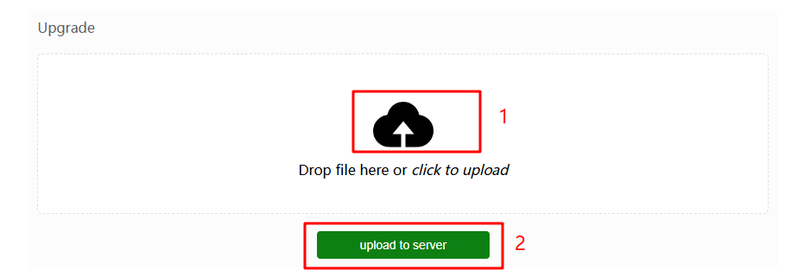
● Restore to factory settings: restores factory configuration.

2.4 Command Line Configuration
This device supports command-line configuration. In case of abnormal situations, you can view logs via the serial port to troubleshoot issues.

2.4.1 Serial Port Connection
As shown in the figure below, connect the TTL interface. The board silkscreen and pin header order correspond one-to-one. Note that TX and RX are cross-connected, i.e., TX->RX, RX->TX. If the pin headers are not soldered on the board, you need to solder them manually. After serial port connection, the device will automatically output logs.
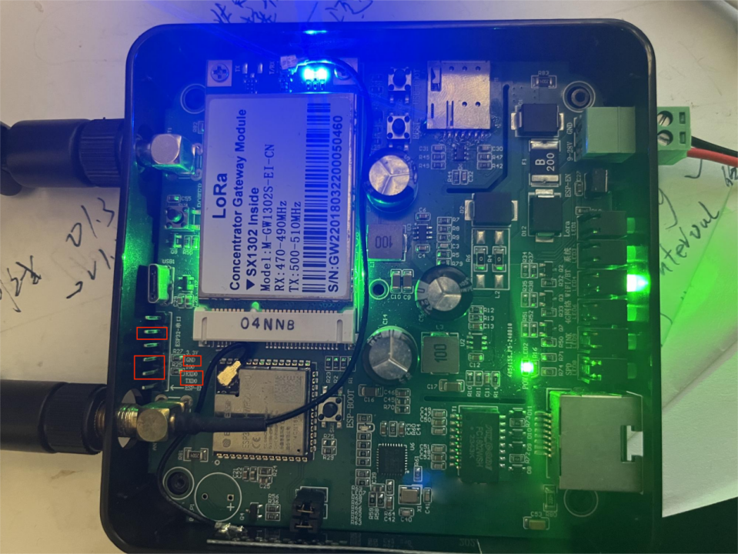

2.4.2 Command Description
The device supports command-line configuration. Please use PuTTY or Xshell. Serial port configuration: 115200, 8, N, 1.
Note:
1. Any parameter modification requires a restart to take effect, meaning you need to enter the reboot command
● help: view all commands
255MG-801> help
pkt_fwd [-h] [--restore] [--host=<UDP Host>] [--port=<UDP Port>] [--gwid=<gateway id>]
ESP32 packet forwarder based on sx1302_hal
--restore clean NVS config
-h, --help print help
--host=<UDP Host> UDP Host
--port=<UDP Port> UDP Port
--gwid=<gateway id> Gateway Id
​
ifconfig
printf network status
​
reboot
reboot the system
​
wifi
set wifi parameters
​
help [<string>]
Print the summary of all registered commands if no arguments are given,
otherwise print summary of given command.
<string> Name of command
As shown above, you can configure via the pkt_fwd command
● pkt_fwd: used to configure pkt_fwd-related information, including NS address and port
● ifconfig: used to view all network interface information
255MG-801>
255MG-801> ifconfig
​
=========ifconfig===========
--------if:ppp prio:20--------
link: NET_UP
ip: 10.145.122.176
mask: 255.255.255.255
gw: 10.64.64.64
dns1: 218.85.157.99
dns2: 218.85.157.99
IMEI: 860761079936981
IMSI: 460115210945489
ICCID: 89860322245923849833
CSQ/BER: 23/0
--------if:eth prio:50--------
link: LINK_DOWN/NET_DOWN
MAC: 66:e8:33:49:ba:47
ip: 0.0.0.0
mask: 0.0.0.0
gw: 0.0.0.0
dns1: 218.85.157.99
dns2: 218.85.157.99
--------if:ap prio:10--------
MAC: 64:e8:33:49:ba:45
ip: 192.168.4.1
ssid: esp32
pswd: esp32wifi
=========ifconfig end===========
255MG-801>
● wifi: used to view and set WIFI SSID and password
◆ Read WIFI configuration
255MG-801> wifi
wifi_ssid:jiji
wifi_pswd:redmi
◆ Configure WIFI connection, format: wifi {ssid} {password}
255MG-801> wifi 255mesh 255mesh123456
set wifi_ssid: Done
set wifi_pswd: Done
set ns_host: Done
set ns_port: Done
set gw_id: Done
set wifi_mode: Done
set freq_region: Done
set freq_radio0: Done
set freq_radio1: Done
set mgt_enable: Done
set mgt_url: Done
set mgt_type: Done
set mgt_clientid: Done
set mgt_username: Done
set mgt_tsbd_tele: Done
set mgt_tsbd_req: Done
set mgt_tsbd_resp: Done
set mgt_uptopic: Done
set mgt_dntopic: Done
set cfg_inited: Done
set eth_cfg: Done
set restart_plan: Done
set dns_cfg: Done
Save config to NVS... Done
​
255MG-801> wifi
wifi_ssid:255mesh
wifi_pswd:255mesh123456
255MG-801>
● reboot: used to restart the device. Any parameter modification requires a restart to take effect

3. Function Introduction

3.1 Multi-Network Interface Management
The device supports up to 3 network access methods:
● WIFI STA
● Ethernet
● 4G
The selection of these three network access methods follows the network interface readiness status and priority.
● Readiness status: when this method can obtain an IP address, the network interface is considered ready;
● Priority: WIFI STA > Ethernet > 4G;
● Network interface selection logic: the device always selects the highest-priority ready network interface for communication.

3.2 LED Indicator Status
LED indicator details are as follows:
● RF-LED: The LoRaWAN module is in receive mode. Lit when receiving, off when transmitting.
● SYS-LED:
◆ System started, LoRaWAN thread not started: on 0.5s, off 0.5s.
◆ System started, LoRaWAN thread started: steady on.
● WIFI-LED:
◆ WIFI STA not enabled: steady off
◆ WIFI STA searching for network: on 0.5s, off 0.5s.
◆ WIFI STA connected: steady on.
● 4G-LED: on 0.2s, off 1.8s; network searching state.
◆ On 1.8s, off 0.2s; standby state.
◆ On 0.125s, off 0.125s; data transmission state.
● LINK-LED: Ethernet port running normally, this LED flashes.
● SPD-LED: Ethernet port running normally, this LED steady on.

4. Acceptance Testing Method
1. Power on the device;
2. Connect to the device's WIFI hotspot (SSID: LoRaGW-xxxxxx, password: loragwwifi). Enter http://192.168.4.1 in the browser to view the device configuration page;http://192.168.4.1
3. Test Ethernet: connect the device to a router. If the device can obtain an IP via DHCP, Ethernet is functioning properly;
4. After the device is networked, the SX1302 module starts. Enter the device's GWID (default GWID is the SN) into the NS server. If the gateway appears online on the NS server, the SX1302 is functioning properly;
5. Insert a 4G SIM card and unplug the Ethernet cable. If 4G obtains an IP address properly, 4G is functioning properly;
6. All hardware functions have been verified. Testing passed.

5. NS Connection
The gateway uses the UDP Packet-forward protocol to connect with NS. This protocol was designed by Semtech and is widely used between LoRaWAN gateways and NS.

5.1 Connecting with ChirpStack
Enter the information as shown in the figure below
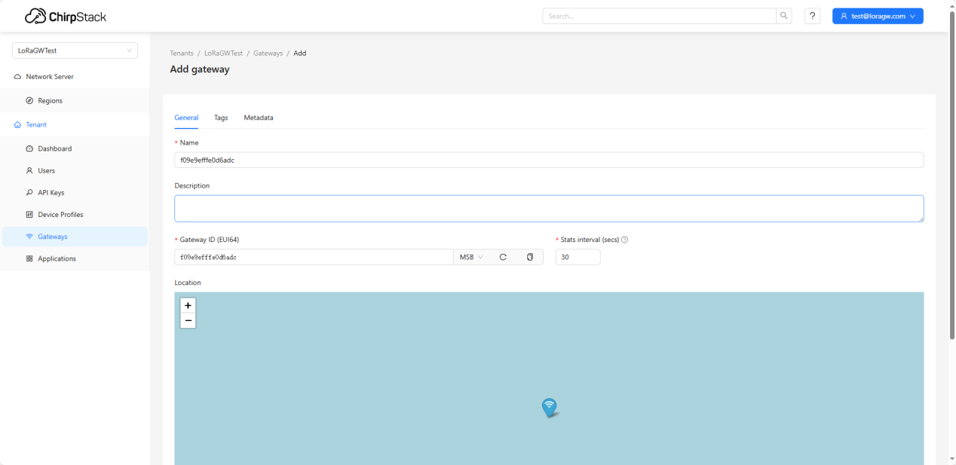
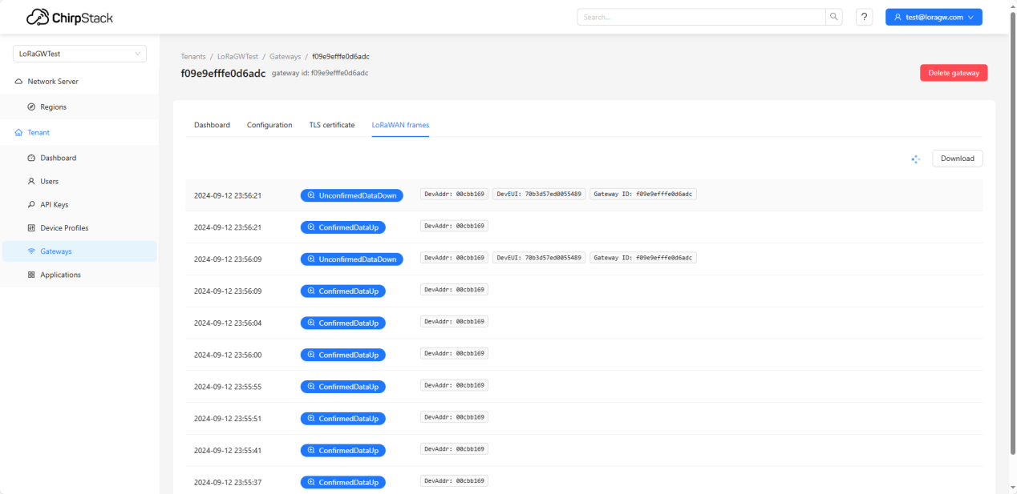

Connecting with TTN
Gateway information entry
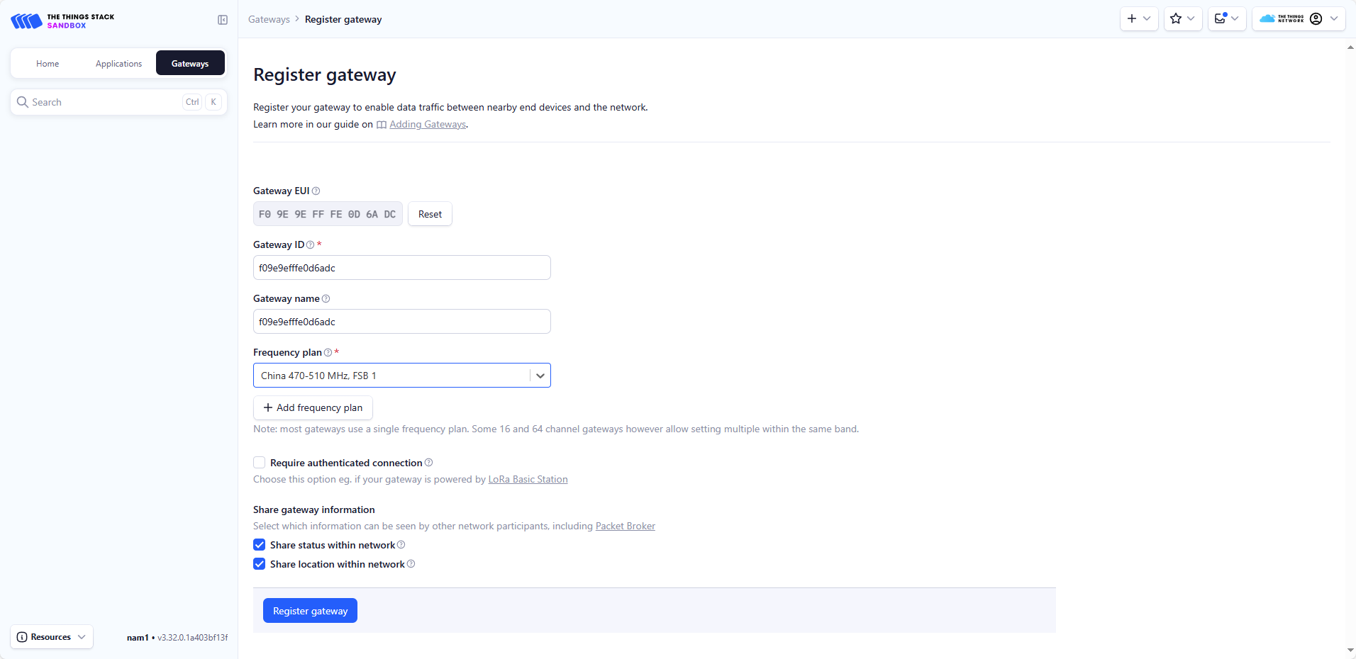
Gateway is online, uplink data can be seen
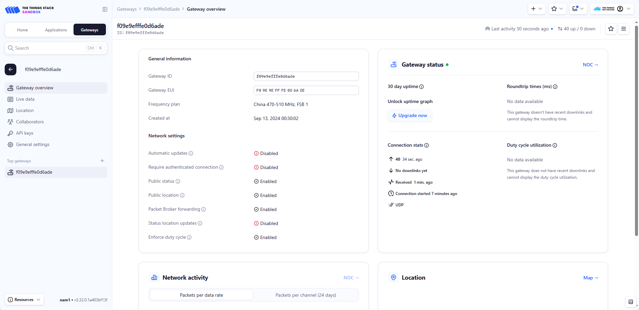

6. Gateway Configuration Channel

6.1 Standard MQTT Channel
The configuration channel uses MQTT for data interaction. The channel from the device to the server is called the uplink channel, and the channel from the server to the device is called the downlink channel.
Where:
● Uplink Topic:up/gw/{SN}/0
● Downlink Topic:dn/gw/{SN}/0
For example, if the gateway SN is 64e833fffe5909d8, the uplink and downlink channels are:
● Uplink Topic:up/gw/64e833fffe5909d8/0
● Downlink Topic:dn/gw/64e833fffe5909d8/0
The gateway periodically sends heartbeat packets through the uplink channel
The server can also send data to the gateway through the downlink channel

6.1.1 Periodic Packet

{
"pkt": "periodUplink",
"GWInfo": {
"SN": "64e833fffe5909d8",
"SoftwareVersion": "V1.0.1",
"HardwareVersion": "V1.0.0"
},
"Staus": {
"GPSValid": true,
"Latitude": 24.000000,
"Longitude": 120.000000,
"Altitude": 0.000000,
"Cellular": {},
"Ethernet": {},
"WIFI": {
"Link": "NET_UP",
"IPMode": "DHCP",
"MAC": "64:e8:33:59:09:d8",
"IP": "192.169.4.12",
"Mask": "255.255.255.0",
"GW": "192.169.4.1",
"DNS1": "192.169.4.1",
"DNS2": "192.169.4.1"
}
},
"Configuration": {
"STA": {
"Enable": false,
"SSID": "",
"Password": ""
},
"Management": {
"MQTT": {
"Enable": true,
"URL": "mqtt://broker.emqx.io",
"ClientID": "64e833fffe5909d8",
"UplinkTopic": "up/gw/64e833fffe5909d8/0",
"DownlinkTopic": "dn/gw/64e833fffe5909d8/0"
}
},
"LoRaWAN": {
"Region": "cn470",
"Radio0": "470600000",
"Radio1": "enable",
"NsHost": "lora.ansitw.com",
"NsPort": "1700",
"GatewayID": "64e833fffe5909d8"
}
}
}

6.1.2 Modify Gateway Configuration
Directly modify the content in Configuration and send it down
{
"pkt": "downlink",
"Configuration": {
"STA": {
"Enable": false,
"SSID": "",
"Password": ""
},
"Management": {
"MQTT": {
"Enable": true,
"URL": "mqtt://broker.emqx.io",
"ClientID": "64e833fffe5909d8",
"UplinkTopic": "up/gw/64e833fffe5909d8/0",
"DownlinkTopic": "dn/gw/64e833fffe5909d8/0"
}
},
"LoRaWAN": {
"Region": "cn470",
"Radio0": "470600000",
"Radio1": "enable",
"NsHost": "lora.ansitw.com",
"NsPort": "1700",
"GatewayID": "64e833fffe5909d8"
}
}
}
Response:
{
"pkt": "downlinkRespone",
“result”:"success"
}

6.1.3 Reboot
{
"pkt": "downlink",
"cmd": {
"reboot": true
}
}
Response
{
"pkt": "downlinkRespone",
“result”:"success"
}

6.1.4 Upgrade
{
"pkt": "downlink",
"cmd": {
"upgrade": "http://192.169.4.53/esp32_sx1302.bin"
}
}
Response (upgrade command received)
{
"pkt": "downlinkRespone",
“result”:"success"
}

6.2 ThingsBoard MQTT Channel
The configuration channel uses MQTT for data interaction. Data sent from the gateway to the cloud platform is called uplink, and commands sent from the cloud platform to the gateway are called downlink.
There are two links:
1. Gateway actively sends data
◆ telemetry_uplink
● The device sends heartbeat packets periodically
● The device sends configuration information upon power-up and when configuration changes
2. Cloud platform sends commands to the gateway
◆ request_downlink: cloud platform sends commands to the gateway
◆ respone_uplink: gateway responds with data to the cloud platform
Where:
● telemetry_uplink_topic:v1/devices/me/telemetry
● request_downlink_topic:v1/devices/me/rpc/request/${request_id
● respone_uplink_topic: v1/devices/me/rpc/response/${request_id}
For example, if the current message's request_id of the gateway is 10001, the uplink and downlink channels are:
● telemetry_uplink_topic:v1/devices/me/telemetry
● request_downlink:v1/devices/me/rpc/request/10001
● respone_uplink: v1/devices/me/rpc/response/10001

6.2.1 Gateway Information Packet
1. Sent when the device powers up or configuration is modified
2. The device sends once every 1 hour
{
"ts":1451649600512,
"values":
{
"pkt":"gw_info",
"SN":"64e833fffe5909d8", //Device serial number
"swver":"V1.0.1", //Software version
"hwver":"V1.0.0", //Hardware version
"longitude": "24.56789", //Longitude
"latitude": "118.56789", //Latitude
"altitude": "78.965", //Altitude
"stat_cell_link":"", //stat is abbreviation of status, stat-prefix fields are read-only, cell is abbreviation of cellular, this is the cellular link status, NET_UP means connected, NET_DOWN means not connected
"stat_cell_ip": "", //IP obtained by cellular
"stat_cell_IMEI": "", //IMEI of cellular module
"stat_cell_IMSI": "", //IMSI of SIM card
"stat_cell_ICCID": "", //ICCID of SIM card
"stat_cell_CSQ": "", //Cellular signal strength
"stat_eth_link": "", //ETH is abbreviation of Ethernet, this is the Ethernet link status, format is LINK_UP/NET_UP, where LINK_UP means cable inserted, LINK_DOWN means cable not inserted, NET_UP means connected, NET_DOWN means not connected
"stat_eth_mac": "", //MAC address of Ethernet
"stat_eth_ip": "", //IP address of Ethernet
"stat_eth_mask": "", //Subnet mask of Ethernet
"stat_eth_gw": "", //Gateway of Ethernet
"stat_eth_dns1": "", //DNS1 of Ethernet
"stat_eth_dns2": "", //DNS2 of Ethernet
"stat_sta_link": "", //STA is abbreviation of WiFi Station, meaning the device connects to a WiFi AP in station mode, this is the WiFi link status, NET_UP means connected, NET_DOWN means not connected
"stat_sta_mac": "", //MAC address of WiFi
"stat_sta_ip": "", //IP address of WiFi
"stat_sta_mask": "", //Subnet mask of WiFi
"stat_sta_gw": "", //Gateway of WiFi
"stat_sta_dns1": "", //DNS1 of WiFi
"stat_sta_dns2": "", //DNS2 of WiFi
"conf_sta_enable":"", //conf is abbreviation of configuration, sta is abbreviation of station, sta_enable indicates whether WiFi station is enabled, true means enabled, false means disabled
"conf_sta_ssid":"", //Configured WiFi SSID to connect to
"conf_sta_password":"", //Configured WiFi password to connect to
"conf_lorawan_region": "", //Configured LoRaWAN region
"conf_lorawan_radio0":"", //Configured LoRaWAN radio0
"conf_lorawan_radio1":"", //Configured LoRaWAN radio1
"conf_lorawan_nshost":"", //Configured LoRaWAN NS host
"conf_lorawan_nsport":"", //Configured LoRaWAN NS port
"conf_lorawan_gatewayid":"" //Configured LoRaWAN gateway ID
}
}

6.2.2 Heartbeat Packet
{
"ts":1451649600512,
"values":{
"pkt":"heartbeat",
"SN":"64e833fffe5909d8"
}
}

6.2.3 Modify Gateway Configuration
Directly modify the content in Configuration and send it down
{
"method": "modify_configuration", //gateway_reboot is the command keyword
"params": {
"sta_enable": true,
"sta_ssid": "",
"sta_password": "",
"mang_mqtt_url": "mqtt://thingsboard.com:6883",
"mang_mqtt_clientid": "64e833fffe5909d8",
"mang_mqtt_username": "",
"mang_mqtt_password": "",
"mang_mqtt_telemetry_topic": "v1/devices/me/telemetry",
"mang_mqtt_request_topic": "v1/devices/me/rpc/request", // This path is only partial; a request_id needs to be appended when actually sending
"mang_mqtt_respone_topic": "v1/devices/me/rpc/response", // This path is only partial; a request_id needs to be appended when actually sending
"lorawan_region": "cn470",
"lorawan_radio0": "470600000",
"lorawan_radio1": "471400000",
"lorawan_nshost": "lora.ansitw.com",
"lorawan_nsport": "1700",
"lorawan_gatewayid": "471400000"
}
}
Response:
{
"result": "success",
"resp": { // Results are placed in this structure
"method": "modify_configuration"
}
}

6.2.4 Query Gateway Status and Configuration
{
"method": "query_gw_info", //gateway_reboot is the command keyword
"params": { }
}

Response:
{
"result": "success",
"resp": {
"method": "query_gw_info",
"pkt":"gw_info",
"SN":"64e833fffe5909d8", //Device serial number
"swver":"V1.0.1", //Software version
"hwver":"V1.0.0", //Hardware version
"longitude": "24.56789", //Longitude
"latitude": "118.56789", //Latitude
"altitude": "78.965", //Altitude
"stat_cell_link":"", //stat is abbreviation of status, stat-prefix fields are read-only, cell is abbreviation of cellular, this is the cellular link status, NET_UP means connected, NET_DOWN means not connected
"stat_cell_ip": "", //IP obtained by cellular
"stat_cell_IMEI": "", //IMEI of cellular module
"stat_cell_IMSI": "", //IMSI of SIM card
"stat_cell_ICCID": "", //ICCID of SIM card
"stat_cell_CSQ": "", //Cellular signal strength
"stat_eth_link": "", //ETH is abbreviation of Ethernet, this is the Ethernet link status, format is LINK_UP/NET_UP, where LINK_UP means cable inserted, LINK_DOWN means cable not inserted, NET_UP means connected, NET_DOWN means not connected
"stat_eth_mac": "", //MAC address of Ethernet
"stat_eth_ip": "", //IP address of Ethernet
"stat_eth_mask": "", //Subnet mask of Ethernet
"stat_eth_gw": "", //Gateway of Ethernet
"stat_eth_dns1": "", //DNS1 of Ethernet
"stat_eth_dns2": "", //DNS2 of Ethernet
"stat_sta_link": "", //STA is abbreviation of WiFi Station, meaning the device connects to a WiFi AP in station mode, this is the WiFi link status, NET_UP means connected, NET_DOWN means not connected
"stat_sta_mac": "", //MAC address of WiFi
"stat_sta_ip": "", //IP address of WiFi
"stat_sta_mask": "", //Subnet mask of WiFi
"stat_sta_gw": "", //Gateway of WiFi
"stat_sta_dns1": "", //DNS1 of WiFi
"stat_sta_dns2": "", //DNS2 of WiFi
"conf_sta_enable":"", //conf is abbreviation of configuration, sta is abbreviation of station, sta_enable indicates whether WiFi station is enabled, true means enabled, false means disabled
"conf_sta_ssid":"", //Configured WiFi SSID to connect to
"conf_sta_password":"", //Configured WiFi password to connect to
"conf_lorawan_region": "", //Configured LoRaWAN region
"conf_lorawan_radio0":"", //Configured LoRaWAN radio0
"conf_lorawan_radio1":"", //Configured LoRaWAN radio1
"conf_lorawan_nshost":"", //Configured LoRaWAN NS host
"conf_lorawan_nsport":"", //Configured LoRaWAN NS port
"conf_lorawan_gatewayid":"", //Configured LoRaWAN gateway ID
"mang_mqtt_url": "mqtt://thingsboard.com:6883", //mang is abbreviation of management, this is the MQTT URL of the management channel, format: mqtt://host:port
"mang_mqtt_clientid": "64e833fffe5909d8",//This is the MQTT ClientID
"mang_mqtt_username": "", //This is the MQTT username
"mang_mqtt_password": "", //This is the MQTT password
"mang_mqtt_telemetry_topic": "v1/devices/me/telemetry", //This is the ThingsBoard telemetry topic
"mang_mqtt_request_topic": "v1/devices/me/rpc/request", //This is the ThingsBoard RPC request topic
"mang_mqtt_respone_topic": "v1/devices/me/rpc/response", //This is the ThingsBoard RPC response topic, request_id will be appended
}
}

6.2.5 Reboot
{
"method": "gw_reboot", //gateway_reboot is the command keyword
"params": { }
}
Response
{
"result": "success",
"resp": { // Results are placed in this structure
"method": "gw_reboot"
}
}

6.2.6 Factory Reset
{
"method": "gw_restore", //gw_restore is the command keyword
"params": {}
}
Response
{
"result": "success",
"resp": { // Results are placed in this structure
"method": "gw_restore"
}
}

6.2.7 Upgrade
{
"method": "gw_upgrade", //gateway_reboot is the command keyword
"params": {
"url":"http://192.169.4.53/simple_ota.bin" //The device only supports HTTP URLs
}
}
Response (upgrade command received)
{
"result": "success",
"resp": { // Results are placed in this structure
"method": "gw_upgrade"
}
}

7. Using ChirpStack

7.1 ChirpStack Introduction
ChirpStack is an open-source LoRaWAN NS, widely used for privatized deployment of LoRaWAN NS. It implements various LoRaWAN mechanisms comprehensively.

7.2 Gateway Registration
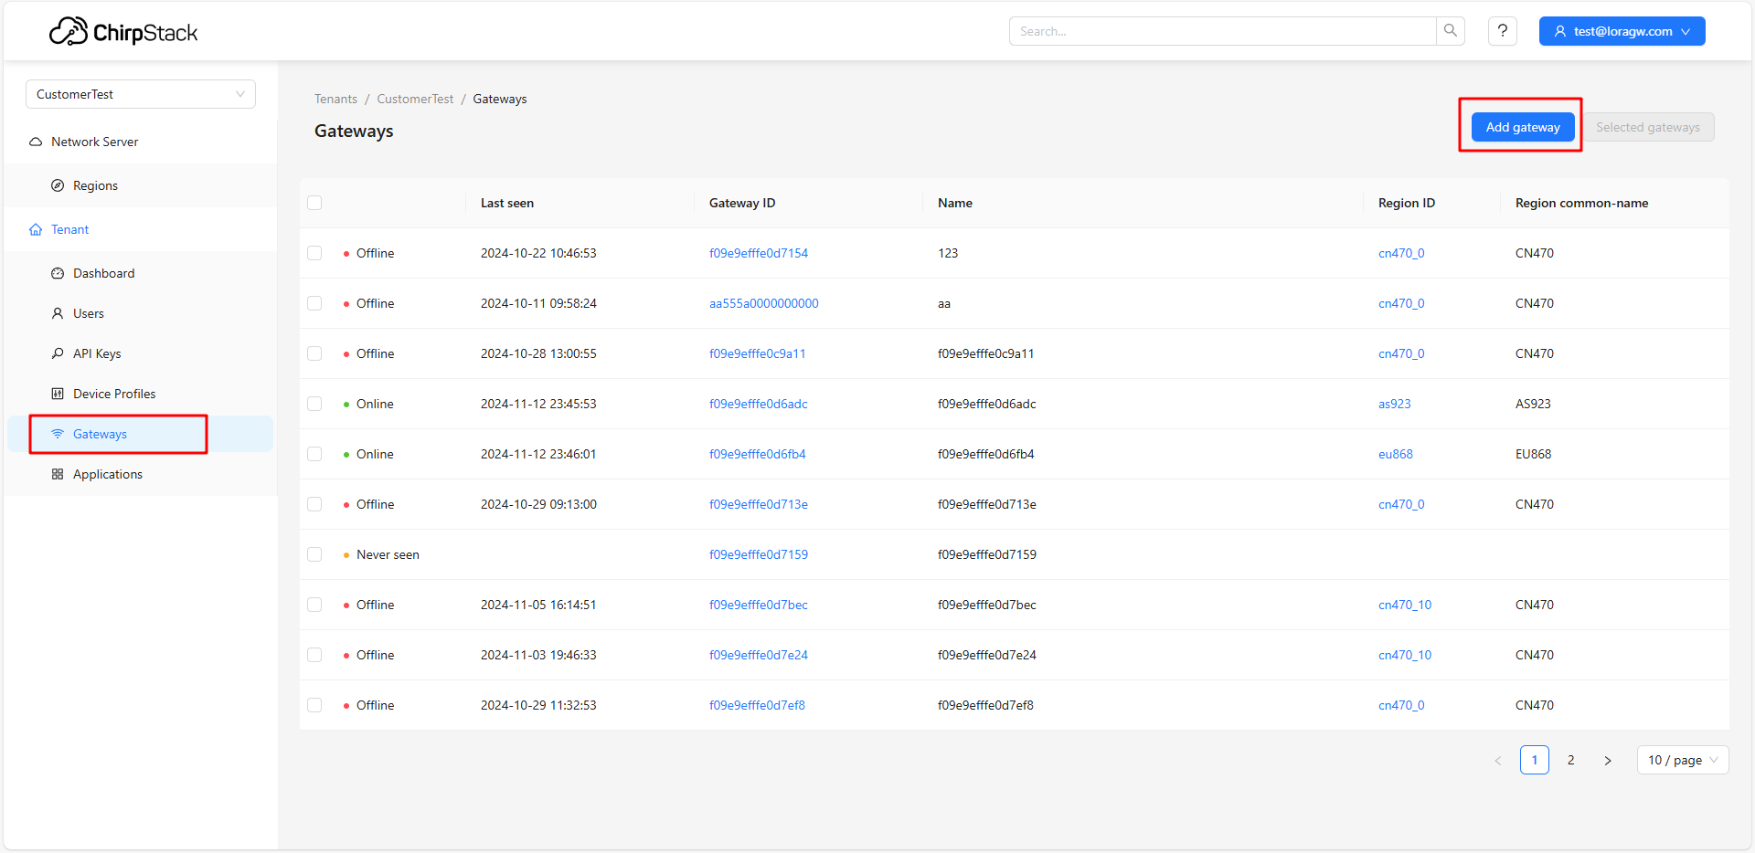
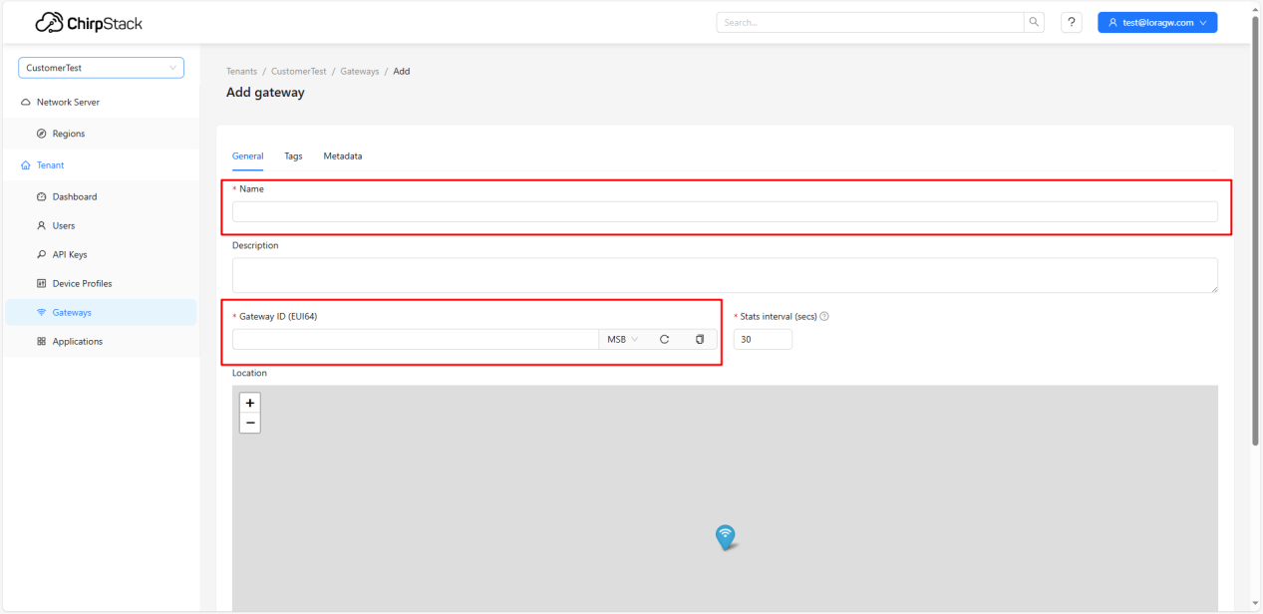
- Name can be any string, or the same as the Gateway ID;
- Copy the gateway's Gateway ID and fill it in;
- After filling, scroll down and click Submit.
Note:
- Clicking Add gateway may show the following error, which can be ignored. This error occurs because foreign maps cannot be used domestically.
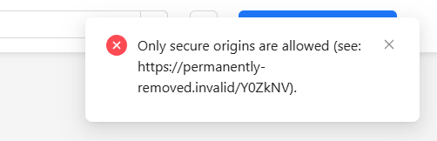

7.3 Device Registration
Adding a device consists of three main steps
- Create Device Profiles for the device; skip if already exists
- Create an Application; skip if already exists
- Add the device to the application, enter device information, and select appropriate Device Profiles

7.3.1 Create Device Profiles
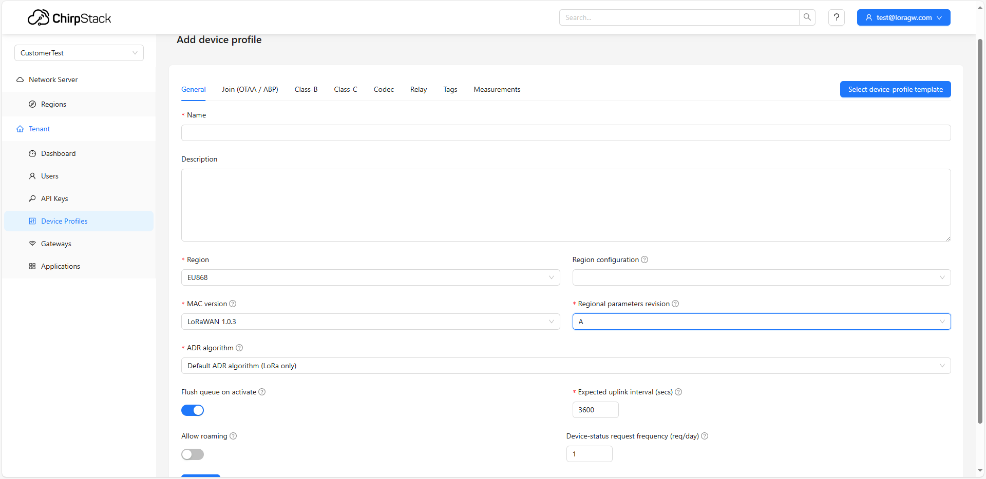
Based on the device, select the appropriate frequency band, join method, and Class

7.3.2 Create Application
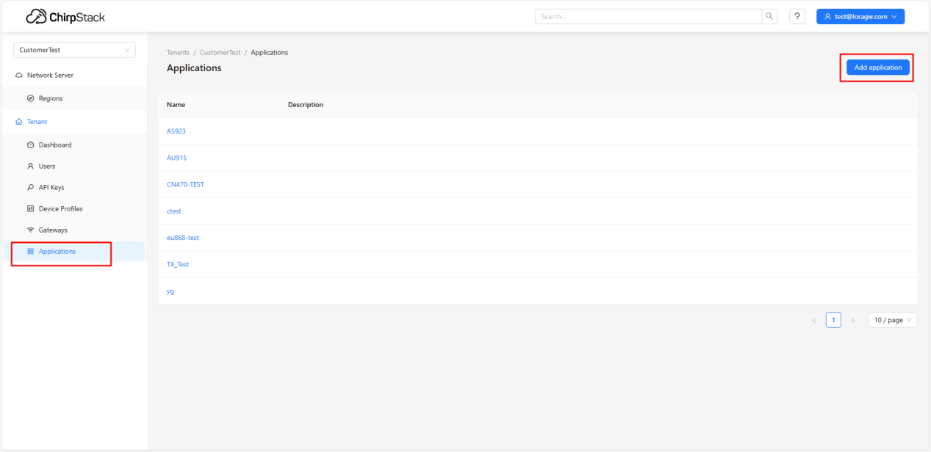
Nothing special. In ChirpStack, devices are organized by Application as units.

7.3.3 Register Device
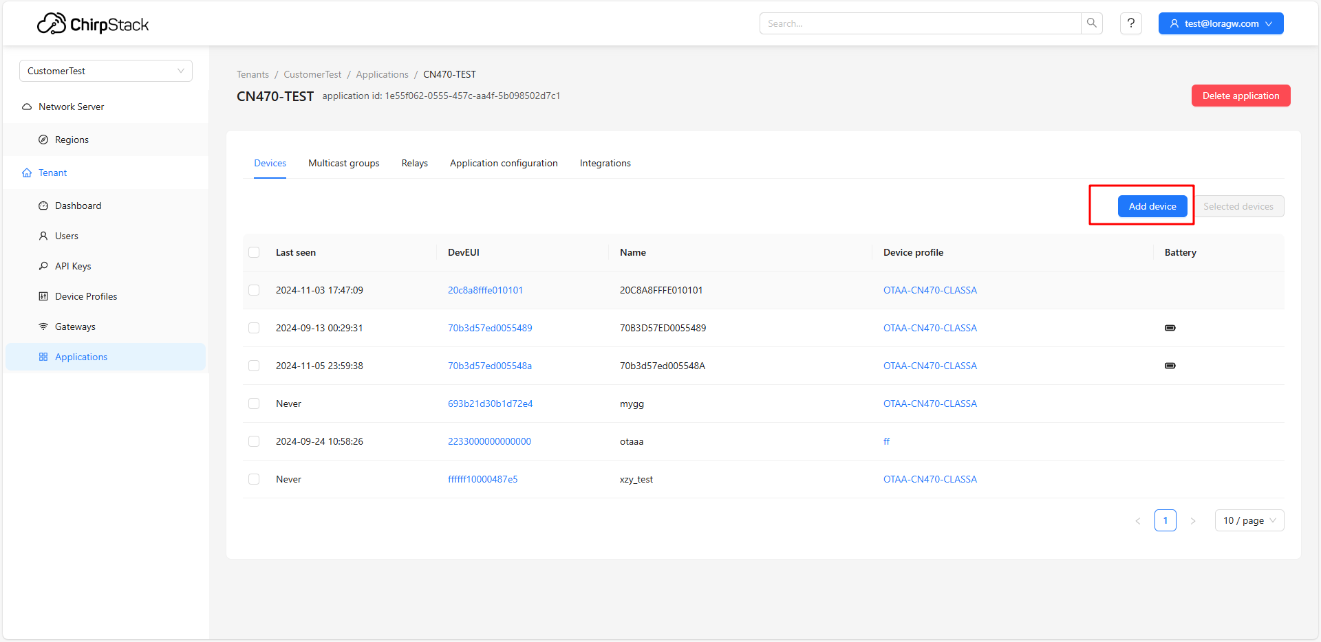
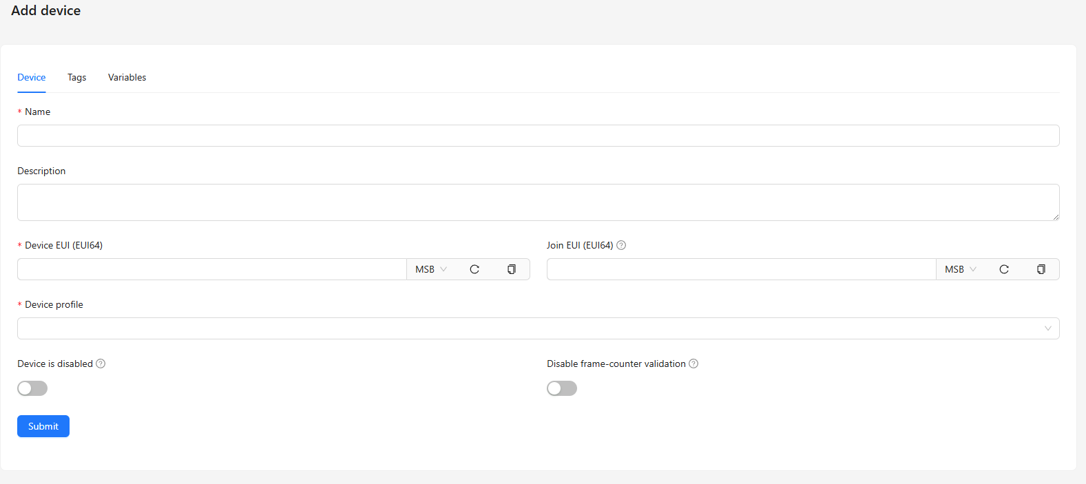
Note:
- Device registration requires entering keys. OTAA and ABP require different keys;
- OTAA's APPEUI (JoinEUI) is plaintext, so it can be left blank.

7.4 View Data

7.4.1 View Gateway Data
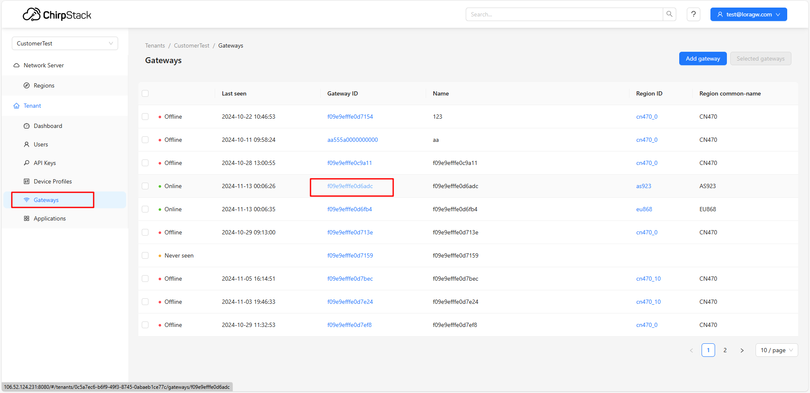
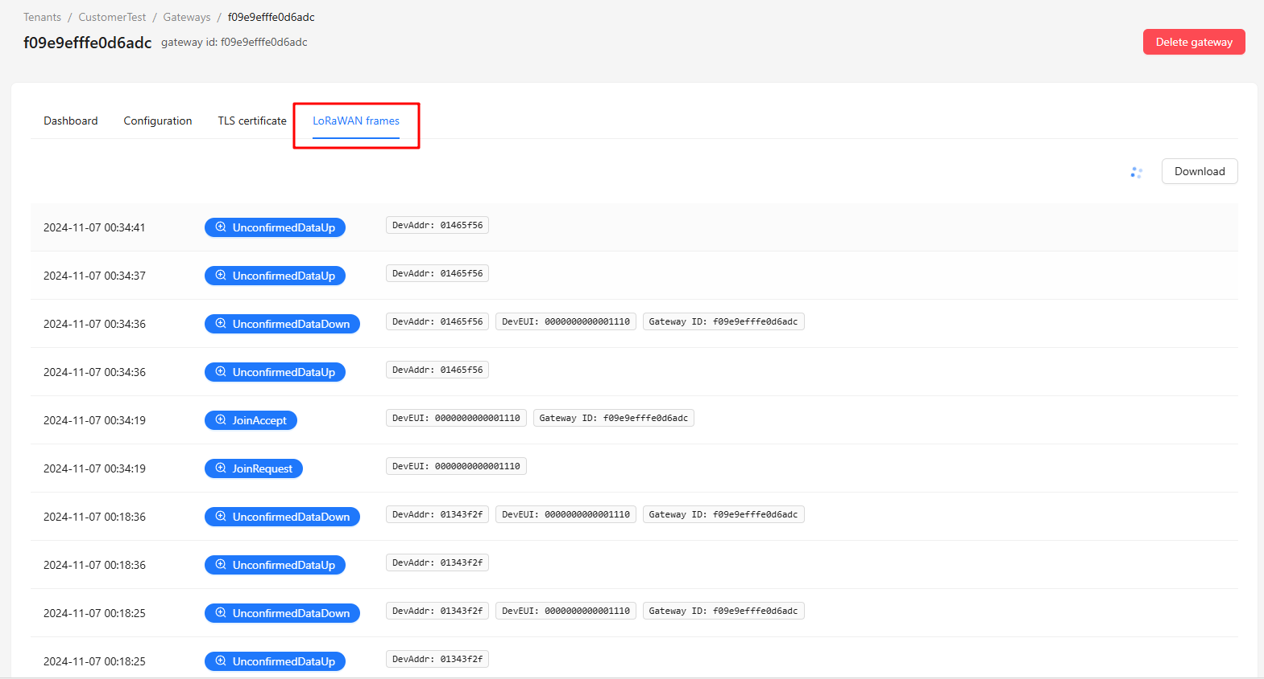
The data viewed here is raw data received and sent by the gateway, so it is encrypted

7.4.2 View Node Data
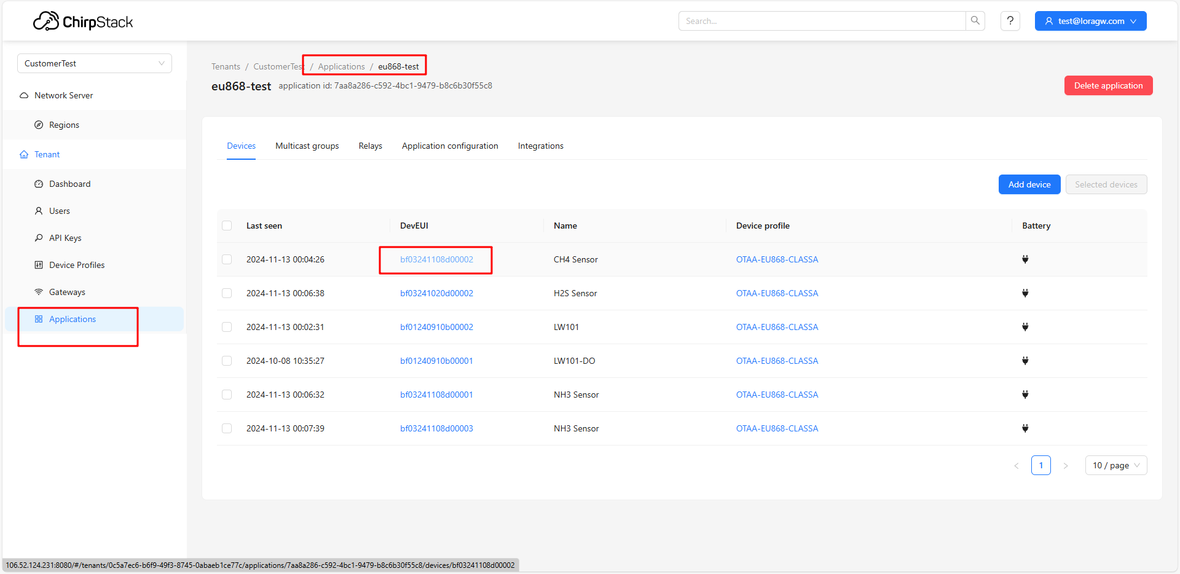
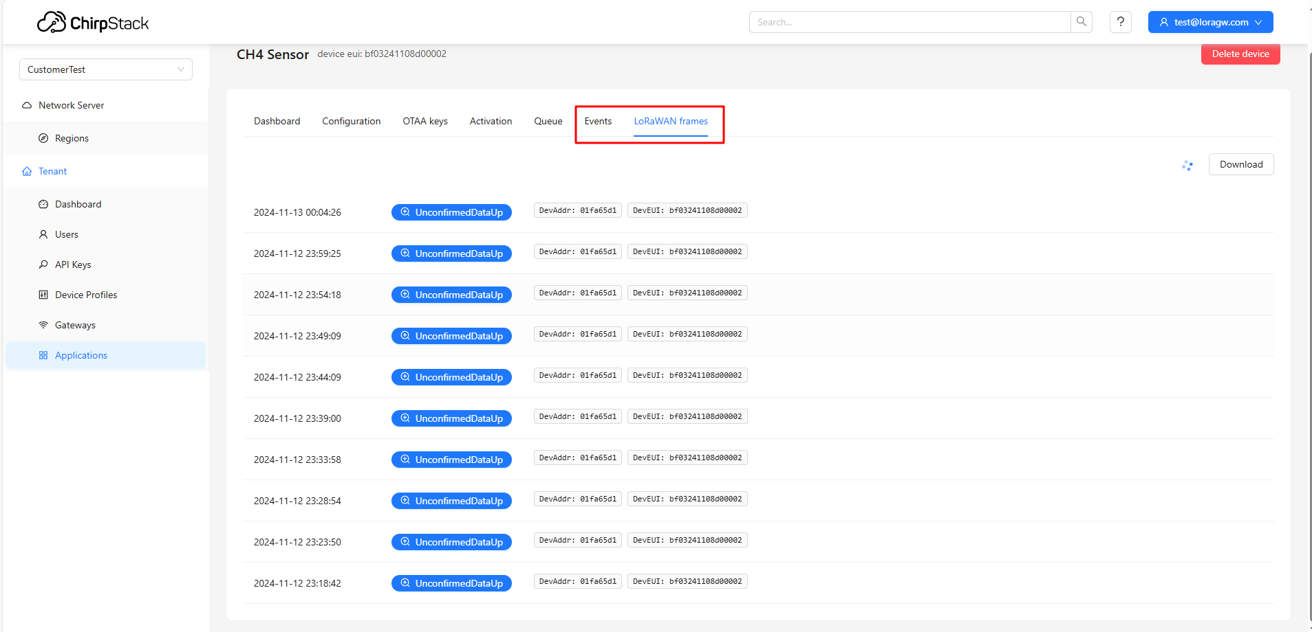
Device uplink/downlink data can be viewed in both Events and LoRaWAN frames. The data in LoRaWAN frames is more raw, showing each data transmission/reception event, including ADR and other MAC Commands.
Note:
1. Because ChirpStack will issue ADR after node joining to adjust the node's ChannelMask based on the connected gateway's frequency channels. If the gateway's frequency channels do not match the actual port frequencies, the node may be modified to non-communicable frequencies, resulting in communication errors.

